# Crop Deal

Low Level Design(LLD)

# 1.Purpose :

# These days, farmers are facing a lot of difficulties when it comes to selling their crops at a fair price. They have to deal with the costs of transporting their produce, waiting for buyers, and negotiating for a reasonable price. Even after selling their products, farmers have to pay various fees and commissions, which can add up and make it challenging for them to make a profit in the market.

We can create a mobile app, available for Android and iOS, that will help farmers sell their products directly to crop purchasers without the need to go to the market. The app will serve as a connection between the farmer and the crop Dealer. Farmers and purchasers can sign up with their details and payment information.

# 2. Intended Audience :

This document is intended as a reference for the following roles as a farmer , dealer and admin in the CropDeal architecture.

# Project Background And Objectives

## i) Project Background :

This project is mainly designed to help the farmers to sell their crops directly to the dealer. Project is using an Api where farmer can put their Crops to be purchased by the dealer.

**ii)Project Objective:**

This Project allows to register a user as a farmer or a dealer . Thus allowing the user (as a farmer) to display the crops , receiving invoices regarding the payments and selecting the crops , make the payments etc. ( as a dealer).

**4.Design Pattern**

|  |  |  |
| --- | --- | --- |
| **Sr. No.** | **Name** | **Description** |
| 1 | Angular  (Frontend) | We will be using Angular as our frontend Technology for Designing the Application. |
| 2 | Web Api | Api is used to perform all CRUD operations based on our Https Request/Response. |
| 3 | Sql server  (backend) | SQL server is used to store data to our database |

# 5.Solution Diagram

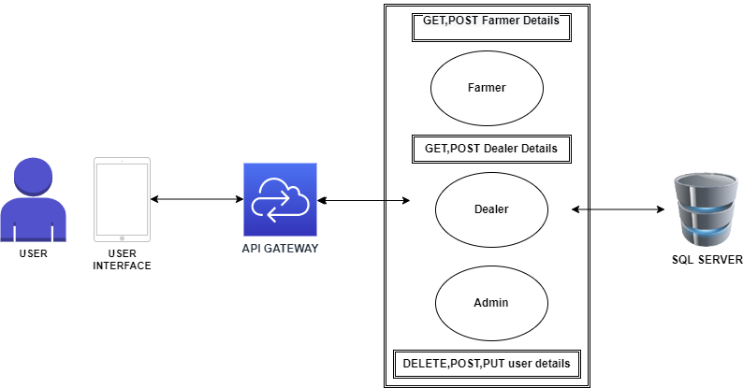

# Architecture Diagram

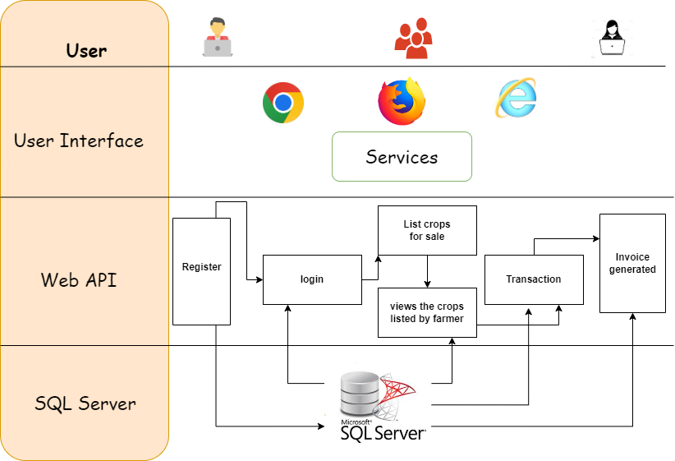

# 7. Flow Diagram

**8.Class Diagram**

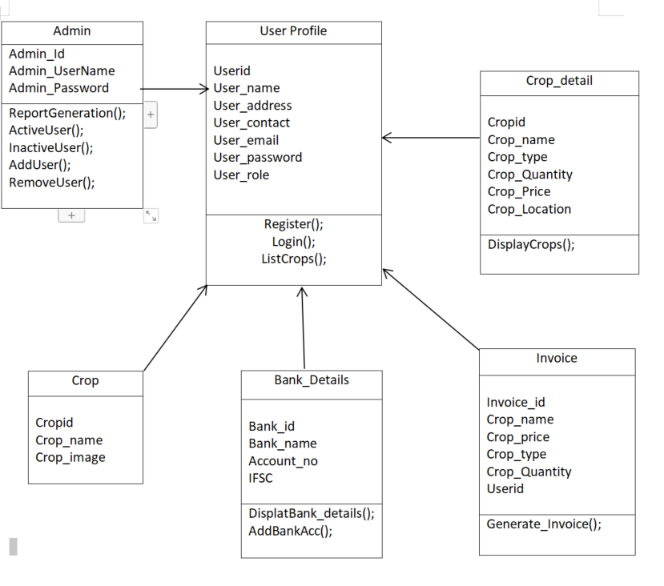

# Solution Steps

**9.1 User Registration**

1. The user will select their role as a farmer or dealer or Admin.
2. The user will enter the name, phone Number, Address and their bank account details during registration.
3. The input validation will be done
4. If validation fails, then it will return the error code and error description. with status code
5. If validation is successful, then the User details is stored in the database and success code is sent.

**9.2 Crop Details**

1. The Farmer will login using his username and password.
2. The Farmer will be posting all the available crops with the Name, quantity, price for sale.
3. After posting all the details regarding the crops the farmer will be waiting for the dealers.

**9.3 Crops Listing**

1. The dealer logins with the id username and password.
2. The dealer sees the all-listed crops that was listed by the various farmers.
3. When the dealer interested in purchasing the crops which was listed by the farmer.
4. The Dealer will click proceed button.

**9.4 Payment**

1. Then Dealer will reach the farmer location and checks the quality and weighs the crops.
2. If the dealer is satisfied with the crop quality and the quantity.
3. He will again login using his login credentials and proceed with the payment.
4. After successful payment an Invoice will be generated and it will be sent to both the farmer and Dealer.
5. **Use Case**

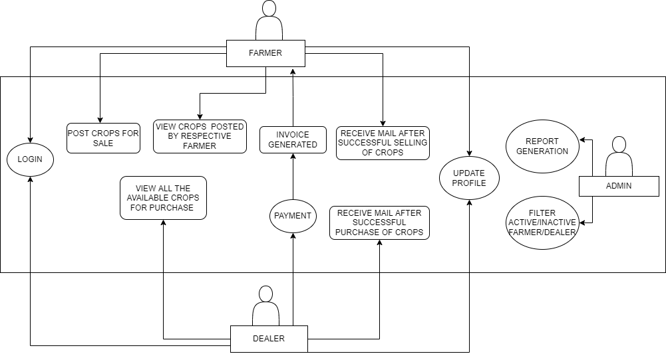

1. **DataBase_Schema**

